

ClickToTalk Mail Client Plug-In

Detail Specification

November 12, 2004

Copyright © 2004 Metreos Corporation
All rights reserved

Proprietary and confidential
For release under NDA only

Table of Contents

Metreos ClickToTalk User Guide 3
ClickToTalk Plug-In Detail Specification 6
Plug-In Appearance and Functionality 6
Actions on Click of Button One 6
Actions on Click of Button Two 8
Metreos ClickToTalk User Guide
Metreos ClickToTalk™ is a speed dialing application permitting the calling of any party or parties in a contact list with a single click. ClickToTalk can be used by anyone in a Cisco CallManager group using a Cisco 7940, 7960, or 7970 IP telephone.

ClickToTalk allows you to select parties to call from your contact list, click a button on the email client user interface, and your IP telephone will dial the selected contact. Calls placed through Metreos ClickToTalk may be recorded, and may include multiparty conference calls.

Integration with Cisco IP Phone Services enables display of called party state on the phone itself. For example, if an invited conferee did not answer, a message so indicating is displayed on your phone. Also included is a robust XML-over-HTTP API, permitting easy integration into other applications such as instant messaging.

Metreos ClickToTalk ships with a plug-in for Microsoft Outlook. Other such plug-ins may easily be developed by your staff or integrator to permit calls from any HTTP-capable endpoint.

Figure 1: ClickToTalk Presence on Outlook Toolbar
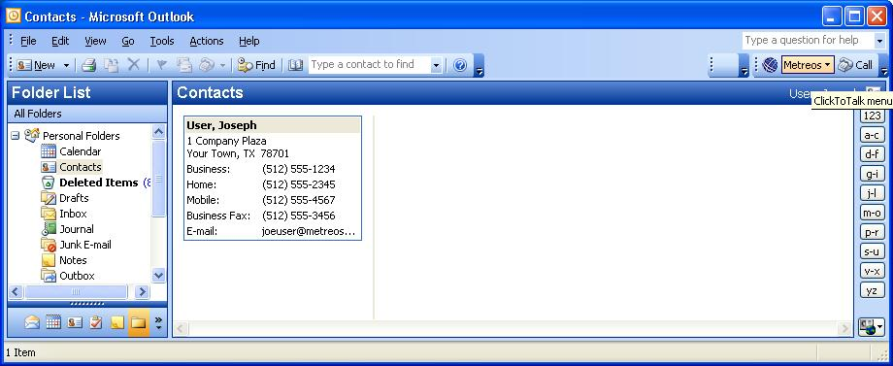

Before You Begin
Before installing the ClickToTalk Outlook plug-in, you or the administrator should ensure that:
- The Metreos runtime environment is running, and that the administrator has informed you of the IP address and port number ClickToTalk should use for connectivity.
- You or the administrator has registered a Metreos Application Suite account for you, and that you have the user name and password for this account at hand. Refer to the Metreos Application Suite Administration Guide for more information.
- You or the administrator has registered the IP phone which will be used to dial your ClickToTalk calls, as the primary device in your Metreos Application Suite account.
- You or the administrator has associated this same IP phone device with a Cisco CallManager user account. Refer to Cisco documents for more information.

Installing the Outlook Plug-In
You should first uninstall any existing Metreos ClickToTalk plug-in, by navigating to the Windows Start menu, Control Panel, Add or Remove Programs, and from there select the Metreos ClickToTalk plug-in for uninstallation, if indeed it had been previously installed.

Your Metreos Application Suite administrator will have provided you with the installation file for the ClickToTalk Outlook plug-in. The installation file will be named setup.exe, unless renamed by the administrator. Double-click on this file to begin installation, and follow the instructions on the ensuing wizard dialogs, accepting all defaults.

Once installation is complete, start Microsoft Outlook and the ClickToTalk button will be found on the Outlook toolbar, as shown in Figure 1.

Configuring the Outlook Plug-In
Before using ClickToTalk for the first time, you will configure ClickToTalk with the information required to log you into the Metreos Application Suite server, and to forward to you any call recordings you may request. This information will be saved in the registry, and as such, need be configured only after installation of ClickToTalk, or in the event that your logon information changes.

Clicking on the ClickToTalk button on the Outlook toolbar (see Figure 1), elicits a menu containing the single entry Settings. Selecting this menu item pops up a Metreos ClickToTalk Settings dialog as shown in Error: Reference source not found.

Figure 2: Client Settings
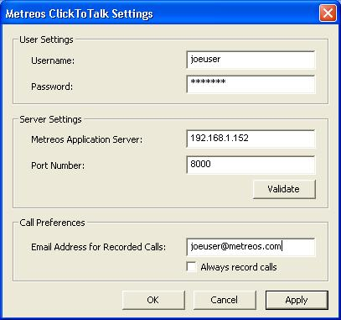

Username/Password
Enter your Metreos Application Suite user name and password, as supplied by the administrator.

Metreos Application Server/Port Number
Enter the Metreos Application Suite IP address, and port number, as supplied by the administrator.

Email Address for Recorded Calls/Always record calls
Enter the email address to which you wish to have sent any call recordings you might request. If you wish to record all calls you initiate, check the box labeled always record calls.

Verifying Connectivity
After entering information into the Metreos ClickToTalk Settings dialog, still Error: Reference source not found, press the button on this dialog labeled Validate, to ensure that connectivity to the Metreos Application Suite runtime environment can be established. A progress bar will be displayed, and you will be presented with a message indicating either that a connection was established, or the connection attempt failed. If successful, this one-time setup is complete, and Metreos ClickToTalk is ready to dial your calls with one click.

If connectivity was not established …
If, however, connectivity could not be established, ensure that:
- The Metreos runtime environment is active.
- You have entered into the Metreos ClickToTalk Settings dialog (Error: Reference source not found, above), the correct IP address and port number for the Metreos runtime environment.
- Your Metreos Application Suite user account has a password associated with it.
- You have entered into the Metreos ClickToTalk Settings dialog the correct account name and password for your Metreos Application Suite user account.

Making a Call
To make a call, simply select an entry in your contact list, and click the Call button (on the ClickToTalk Outlook toolbar, as shown in Figure 1 on page 4). The contact telephone number will be displayed to you at this time, which you can modify if you wish. Your IP phone will dial the selected party, so simply pick up the handset and talk.

Recording your call
At the time you click to talk, a dialog is displayed with the contact telephone number, as described above. To record the call, check the box labeled Record this call, found on this dialog. Of course, if in your ClickToTalk Settings, described earlier, you had specified that all calls were to be recorded, you need not specify that again here. To stop recording the call at any time, press the button labeled Stop Recording, also found on this dialog.

Conferencing
To begin a conference call, simply select multiple (up to four) entries from your contact list and click to talk. Should any party fail to answer, a message so indicating will appear on your phone display. Recording of your conference call is accomplished similarly to recording of a single party call as described above.
ClickToTalk Plug-In Detail Specification
This section provides detailed design and coding instructions for the Mail Client Plug-In component of the Metreos ClickToTalk application.

Plug-In Appearance and Functionality

Installation
The plug-in should be installable to the mail client’s UI with one click, such as by clicking on an installer file. The plug-in installs itself onto the mail client’s main toolbar, if possible, otherwise to a similar area of the client UI.

Content and Appearance
The plug-in should present to the user two buttons or similar clickable UI objects, arranged together on the mail client UI, and bordered such that it is clear that the two button-type objects apply to the same product, namely ClickToTalk. Figure 1 on page 4 shows the plug-in for Microsoft Outlook.

Actions on Click of Button One

Clicking the first button on the plug-in toolbar UI pops a dialog similar to that show in Figure 2: Client Settings on page 4. The purpose of this dialog is to:
- Solicit user and server information which will be used for making calls; and
- Persist this information such that it can be retrieved by subsequent invocations of the plug-in; for example, the Outlook plug-in uses the Windows registry for this purpose.

Client Settings Content
The UI items present on this dialog are:
  - User name text box
  - Password text box
  - Metreos Application Server text box
  - Port Number text box
  - Validate button
  - Email address text box
  - OK button
  - Cancel button
  - Message area or status bar

Client Settings Validation
None of the text boxes may be left empty except the email address field. User name and password need not be validated except for non-empty. The Metreos Application Server box must contain a well-formed dotted-quad IP address. The port number must be a positive integer. Email address, if present, probably does not need to be validated. For any invalid item, show “xxxx is invalid” in the message area, where xxxx is the name of the field.

Validate Button
Clicking the Validate button establishes a TCP connection to the specified IP and port, and if successful, sends the specified user name and password over the connection wrapped by XML. If the connection cannot be established, show “Connection could not be established” in the message area, otherwise HTTP POST some XML over the connection as follows, where xxxxx and yyyyy are the user name and password respectively, as specified by the user on the dialog.

<?xml version="1.0" encoding="utf-8" ?>
<initiateCall username="xxxxx" password="yyyyy" />
If an OK response is not received to the above (see , below), show “User name and/or password invalid” in the message area., otherwise show “Connection verified”.

Waiting to Connect
While waiting to create the TCP connection, either:
- Display a progress bar, as does the Outlook plug-in, or
- Show “Connecting …” in the message area. If you are getting async callbacks, it would be helpful to also show additional periods after this message each second, as a poor man’s progress bar. This is not a requirement, however.

URLs
The URL for all HTTP requests to the Metreos server except Stop Recording will be:
http://%s:%u/click-to-talk/initiateCall
where %s is the IP address supplied in the configuration dialog, and %u the port number.

For Stop Recording, the URL is instead:
http://%s:%u/click-to-talk/stopRecord
The body for all HTTP POST requests except Stop Recording will consist of <initiateCall> XML snippets, as described above and elsewhere in this document.

The body for Stop Recording requests will be empty, if the call is not a conference call, or a plain text string representing the conference ID number, if the call is a conference call. This conference ID number will have been returned with the HTTP response to the initiateCall request, as described below.

The content-type for all HTTP POST requests whose body consists of XML will of course be text/xml, otherwise it will be text/plain.

HTTP Responses
The Metreos server does not return XML to the plug-in. All HTTP POST commands sent from the plug-in elicit HTTP response codes of either 200 (OK) or 400 (error).

When the call is a conference call, and the response code was 200 OK, the response body will consist of a conference ID number as a plain text string. This number should be saved, to be used later if the user asks to Stop Recording.

Cancel Button
If the Cancel button is clicked, dismiss the dialog.

OK Button
This button cause information in the dialog to be persisted to the data store, and the dialog dismissed. Note that the Outlook plug-in also shows an Apply button – this button should not be included.

Actions on Click of Button Two

If no contacts are selected, the second or rightmost button on the toolbar plug-in should be disabled; otherwise clicking this button pops one of two dialogs depending upon whether one or multiple contacts are selected. Figure 3: Single Contact Callillustrates the first case, the single contact call, and Figure 4 illustrates the second, or conference call, case.

Figure 3: Single Contact Call
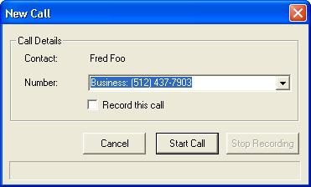

Actions on Start Call button click
When Start Call is clicked on either a single call or conference call dialog, build XML as follows:

<?xml version="1.0" encoding="utf-8" ?>
<initiateCall username="joeuser" password="sesame" record="false" email="joeuser@metreos.com">
<callee name="Joseph User">5125551234</callee>
<callee name="Fred Foo">5124377903</callee>
</initiateCall>

Obviously there will be only one <callee> tag when the call is not a conference call. Note that the record=”booleanstring” parameter is set based upon both the Record this call checkbox on either dialog, and the Always record calls persisted parameter setting.

Note that only digits will be included in the <callee> XML node content; all non-digit characters should be stripped.

Transmit this XML package as described in the URLs section on page 4.

Update message area of this dialog with “Starting call …” and wait for the HTTP response. If response is 200, update message area with “Call is in progress …”, enable the Stop Recording button, and disable the Start Call button. If the response is 400 or timeout, update message area with “Call could not be initiated”.

Figure 4: Conference Call
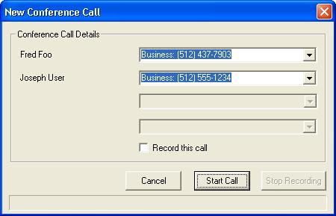

When the call is a conference call, the body of the HTTP response will consist of a plain text string representing the conference ID number. Save this number, to be subsequently transmitted if and when the user clicks Stop Recording.

Actions on Stop Recording button click
Obviously the Stop Recording button is enabled only if the user has checked the Record this call checkbox, or if the Always record calls setting is enabled. When Stop Recording is clicked on either a single call or conference call dialog, send an HTTP POST request to http://%s:%u/click-to-talk/stopRecord, where %s and %u are substituted with the server IP and port as previously, and with the body of the request set to the conference ID string as described in the preceding section. HTTP content-type should of course be text/plain for this request.

Update message area of this dialog with “Attempting to stop recording …” and wait for a response. On any response or timeout, update message area with “Recording stopped”.

